# Steps to Auto Trigger Jenkins to Docker

1. Add your Spring Project in Github repo.
2. Add your Dockerfile in root folder of your Github repo. Like below screen shot.

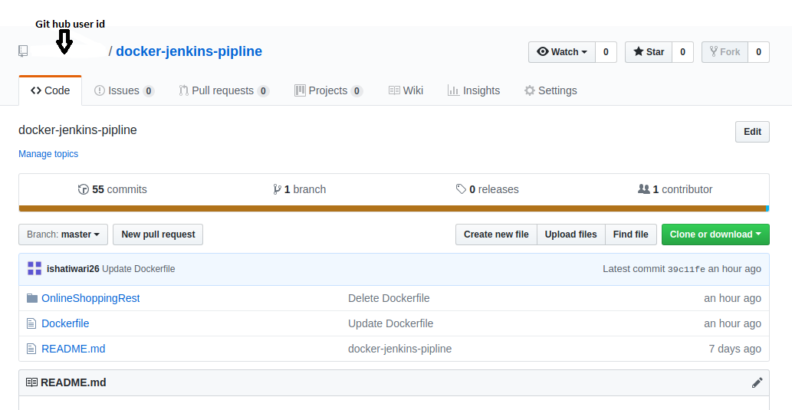

1. Add below lines in Dockerfile as per screen shot.

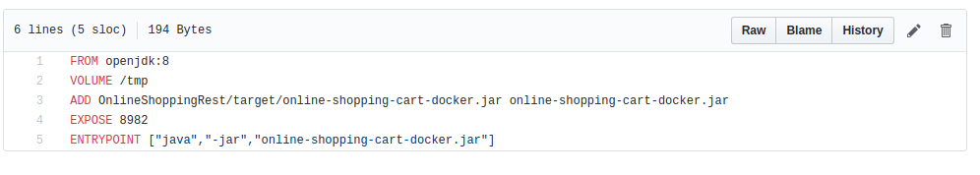

1. Add plugins in Jenkins. Go to Manage Jenkins-> Manage Plugins -> Available
   * 1. Docker Plugins
     2. Github Integration
2. Create New Job. Go to Configure-> Source Code Management-> Select Git. Give your project’s Git repo path and add credential of GitHub.
3. Go to Build -> Add Build Steps -> select Execute Shell. And add below command as per screen shot.

